RESEARCH ARTICLE
Polymorph Stability Index (PSI) for Integrated Assessment of Floristic Families in Surkhandarya (Central Asia)

Otabek Sotiboldiyev¹, Feruz Akbarov¹, Sardor Po‘latov¹, Akram Ibragimov², Komiljon Sh. Tojibaev¹*

¹ Institute of Botany, Academy of Sciences of the Republic of Uzbekistan, Tashkent, Uzbekistan
² Termez State University of Engineering and Agrotechnologies, Termez, Uzbekistan

ktojibaev@mail.ru

ABSTRACT
This study evaluated the dominance of polymorphic floristic families in the flora of Surkhandarya using an integrated, multidimensional approach. A total of 64,619 georeferenced occurrence records representing 2,202 species were analyzed to assess spatial, ecological, and taxonomic patterns. Spatial dominance was quantified using Kernel Density Estimation (KDE) and a triangulation-based approach to estimate the actual area of distribution. Ecological differentiation was assessed through Principal Component Analysis (PCA) and niche breadth, while taxonomic diversity was measured using the Shannon Diversity Index (SDI). The results revealed significant variation among families across all dimensions. Fabaceae, Asteraceae, and Poaceae exhibited the highest spatial coverage and intensity, while ecological analyses showed that niche breadth was not directly correlated with taxonomic richness. The integrated Polymorph Stability Index (PSI) identified those families as the core polymorphic components of the regional flora. Overall, the findings demonstrated that floristic dominance cannot be explained by a single factor, but rather emerges from the combined effects of spatial, ecological, and taxonomic processes. The proposed PSI framework provides a robust and transferable tool for comprehensive floristic analysis in other regions.

Key words: Polymorph Stability Index (PSI); floristic families; spatial analysis; ecological gradients; niche breadth; Surkhandarya

INTRODUCTION

The identification of plant composition in a given region and the assessment of its ecological characteristics are among the key directions of modern ecological research (Haq et al., 2023; Khan et al., 2025). Analyzing the relationships between plant species and environmental factors such as climate, soil, and topography is essential for understanding distribution patterns as well as the mechanisms of adaptation to environmental changes (Bañares-de-Dios et al., 2022). From this perspective, analyzing floristic composition at the family level and determining their spatial and ecological dominance constitute an important scientific task (Ma et al., 2024). In floristic research, the concept of polymorphic floristic families holds particular importance. This concept refers to plant families that exhibit broad geographic distribution, occur across diverse ecological conditions, and are characterized by high internal taxonomic diversity. Such families demonstrate high ecological adaptability and are distinguished by their ability to maintain stable distribution across a wide range of environmental conditions (Slatyer et al., 2013; Mouillot et al., 2013). The degree of polymorphism is an important indicator of the ecological roles and adaptive strategies of plants (Devictor et al., 2010; Slatyer et al., 2013). However, in existing studies, polymorphic floristic families have often been identified using simplified approaches based solely on species richness (Fleishman et al., 2006; Morris et al., 2014). Such approaches do not adequately account for key factors, including ecological adaptability and spatial distribution. For instance, in grid-based mapping studies conducted in the Surkhandarya region, species richness has been used as the primary criterion (Tojibaev et al., 2022; Juramurodov et al., 2025). Therefore, there is a clear need to apply multidimensional approaches for evaluating polymorphic floristic families (Devictor et al., 2010).
Modern ecological research provides opportunities to analyze spatial, ecological, and taxonomic components in an integrated manner. Spatial dominance can be effectively assessed using Kernel Density Estimation (KDE), which quantifies the intensity of species and family distributions (Jana et al., 2024), while geographic range can be estimated using triangulation-based convex hull approaches (Meyer et al., 2020). Ecological dominance can be evaluated through Principal Component Analysis (PCA) (Jolliffe & Cadima, 2016; Legendre & Legendre, 2012) and niche breadth metrics (Slatyer et al., 2013), whereas taxonomic diversity is commonly assessed using the Shannon Diversity Index (Morris et al., 2014).
Based on the integration of these spatial, ecological, and taxonomic components, this study proposes and applies a novel integrative metric—the Polymorph Stability Index (PSI)—to comprehensively evaluate polymorphic floristic families.

2. Materials and Methods

2.1. Data collection and processing
The study was based on georeferenced occurrence records of vascular plants recorded within Surkhandarya Province. The dataset was compiled from field surveys conducted between 2020 and 2024, herbarium collections (ASH, BM, E, H, LE, M, MW, TASH; herbarium acronyms according to Index Herbariorum: Thiers, continuously updated), and open-access sources (plantarium.ru). The final dataset comprised 64,619 occurrence records representing 2,202 species belonging to 615 genera and 96 families. Data quality control involved removing records without geographic coordinates and duplicate entries, resulting in a cleaned dataset of more than 53,000 records. Spatial filtering was applied to retain only records located within the boundaries of Surkhandarya Province. The uneven spatial distribution of occurrence data, a common characteristic of large biodiversity databases, was accounted for (Beck et al., 2014; Meyer et al., 2016). All spatial analyses were performed in the UTM 42N coordinate system (EPSG:32642) to ensure metric accuracy, while visualization was conducted in the WGS84 coordinate system (EPSG:4326).

2.2. Spatial intensity (KDE) and geographic range (convex hull approach)

The spatial intensity of floristic families was quantified using Kernel Density Estimation (KDE), a widely used method for detecting spatial patterns in ecological data (Jana et al., 2024; Meyer et al., 2020). A Gaussian kernel with a bandwidth of σ = 5000 m and a raster resolution of 200 m was used. For each family, the 95th percentile of density values (Q95) was selected as the primary indicator, as it provides a robust measure of high-density areas and is less sensitive to extreme values (Legendre & Legendre, 2012). Geographic range size was estimated using a triangulation–threshold approach based on Delaunay triangulation (Meyer et al., 2020). Triangles with edges longer than 10,000 m were removed, and the remaining triangles were merged to calculate the final area. This approach reduces the overestimation bias commonly associated with the traditional convex hull method, providing a more ecologically realistic estimate of species distribution range.

2.3. Environmental variables and analysis

Climatic, edaphic, and topographic variables were selected for the ecological analysis because those factors are key determinants of plant ecological niche and distribution patterns (Elith & Leathwick, 2009; Franklin, 2010). Bioclimatic variables were obtained from the WorldClim 2.1 database (Fick & Hijmans, 2017), while soil properties were derived from SoilGrids datasets (Hengl et al., 2017). Elevation was used as the topographic variable, as it is a major driver of ecological gradients (Körner, 2007). To reduce multicollinearity, Pearson correlation analysis was performed, and variables with high correlation (|r| ≥ 0.7) were excluded (Dormann et al., 2013). The final model retained five bioclimatic variables, two soil variables, and one elevation variable.
Ecological gradients were identified using Principal Component Analysis (PCA), and then using the first principal component (PCA1) as an integrated indicator of environmental variation (Jolliffe & Cadima, 2016; Legendre & Legendre, 2012). Ecological adaptability was quantified using a variance-based niche breadth index, which enables quantitative assessment of ecological amplitude (Slatyer et al., 2013).

2.4. Taxonomic diversity

The nomenclature and circumscription of vascular plant families follow the Angiosperm Phylogeny Group IV (APG IV) classification (APG, 2016). The use of a standardized and widely accepted taxonomic framework ensures consistency in the delimitation of floristic units and enhances the comparability of taxonomic diversity patterns across datasets. This approach is particularly important for integrated analyses of floristic structure, where the reliability of diversity indices and comparative metrics depends on a uniform taxonomic baseline. Taxonomic diversity was assessed using the Shannon Diversity Index (SDI). This index incorporates both species richness and species relative abundance, providing a comprehensive measure of diversity (Morris et al., 2014).

2.5. Integrated assessment (PSI)

Spatial (Q95 and area), ecological (PCA1 and niche breadth), and taxonomic (SDI) indicators were standardized using min–max normalization.
The components were calculated as follows:
Min–max normalization:
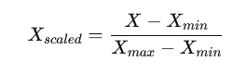
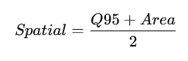
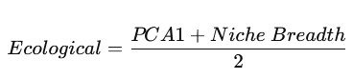
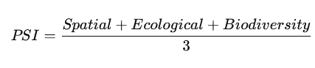
This approach enables a comprehensive, integrated evaluation of the multidimensional dominance of floristic families (Mouillot et al., 2013).

2.6. Software

All analyses were conducted in the R statistical computing environment (R Core Team, 2024). Spatial analyses were performed using the sf and terra packages, statistical analyses with vegan, and data visualization with ggplot2.

3. RESULTS

3.1. Spatial dominance: Kernel Density Estimation (KDE)

Kernel Density Estimation (KDE) analysis revealed substantial variation in the spatial intensity of plant family distributions across the flora of Surkhandarya Province (Fig. 1). Some families formed distinct high-density hotspots in specific parts of the region, whereas others exhibited more dispersed, low-intensity distributions. To quantify spatial intensity, the 95th percentile of KDE values (Q95) was used as the primary indicator, as it provided a robust measure of high-density areas while minimizing sensitivity to extreme values.
According to Q95 values, the highest spatial intensity was recorded for Fabaceae (2.91 × 10⁻⁷). This was followed by Asteraceae (2.36 × 10⁻⁷), Lamiaceae (2.19 × 10⁻⁷), and Poaceae (1.98 × 10⁻⁷), all of which exhibited relatively high local concentration. Intermediate values were observed for Brassicaceae (1.81 × 10⁻⁷) and Apiaceae (1.73 × 10⁻⁷). Lower spatial intensity was found in Boraginaceae (1.51 × 10⁻⁷), Liliaceae (1.32 × 10⁻⁷), and Amaranthaceae (1.29 × 10⁻⁷), while the lowest value was recorded for Ranunculaceae (1.18 × 10⁻⁷).
These findings indicate that spatial dominance is not uniform across families. Some groups act as locally dominant elements with pronounced concentration zones, whereas others follow a broader but lower-intensity distribution strategy. This spatial differentiation is a key component of the subsequent integrative assessment.

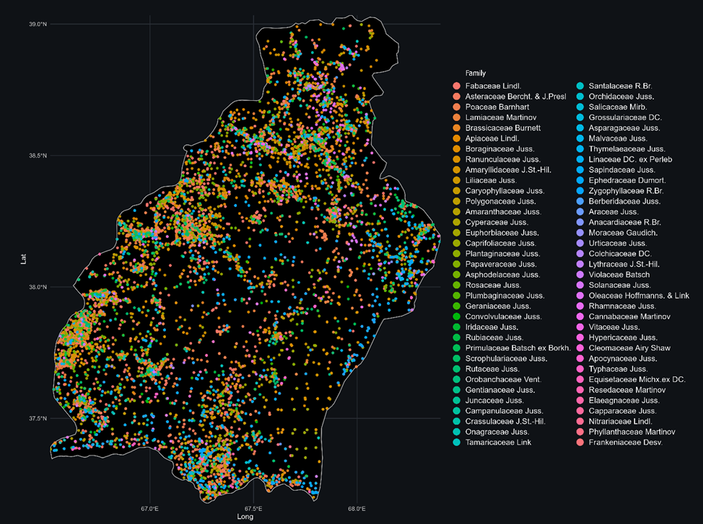
Fig. 1. Spatial distribution density of floristic families in Surkhandarya Province based on Kernel Density Estimation (KDE).

3.2. Spatial dominance: geographic range size (convex hull approach)

The geographic range of floristic families was quantitatively assessed using a Delaunay-based triangulation–threshold approach. The results revealed substantial variation in distribution area among families (Fig. 2). The largest range was recorded for Fabaceae (15,139.2 km²), followed by Asteraceae (13,471.2 km²) and Poaceae (12,512.3 km²). Brassicaceae (12,424.1 km²) and Lamiaceae (11,316.2 km²) also exhibited extensive geographic coverage. Intermediate range sizes were observed for Apiaceae (9,503.1 km²), Amaranthaceae (9,408.8 km²), and Boraginaceae (9,268.5 km²). The smallest ranges were in the Plantaginaceae (8,397.2 km²) and Ranunculaceae (7,267.6 km²).
The triangulation–threshold approach reduced the overestimation of range size by removing long-distance connections between occurrence points. The selected threshold of 10,000 m yielded stable results, as confirmed by a sensitivity analysis across the 8,000–12,000 m range.
Overall, the results indicate that spatial dominance is strongly linked to geographic range size, a key component of the subsequent integrative assessment.

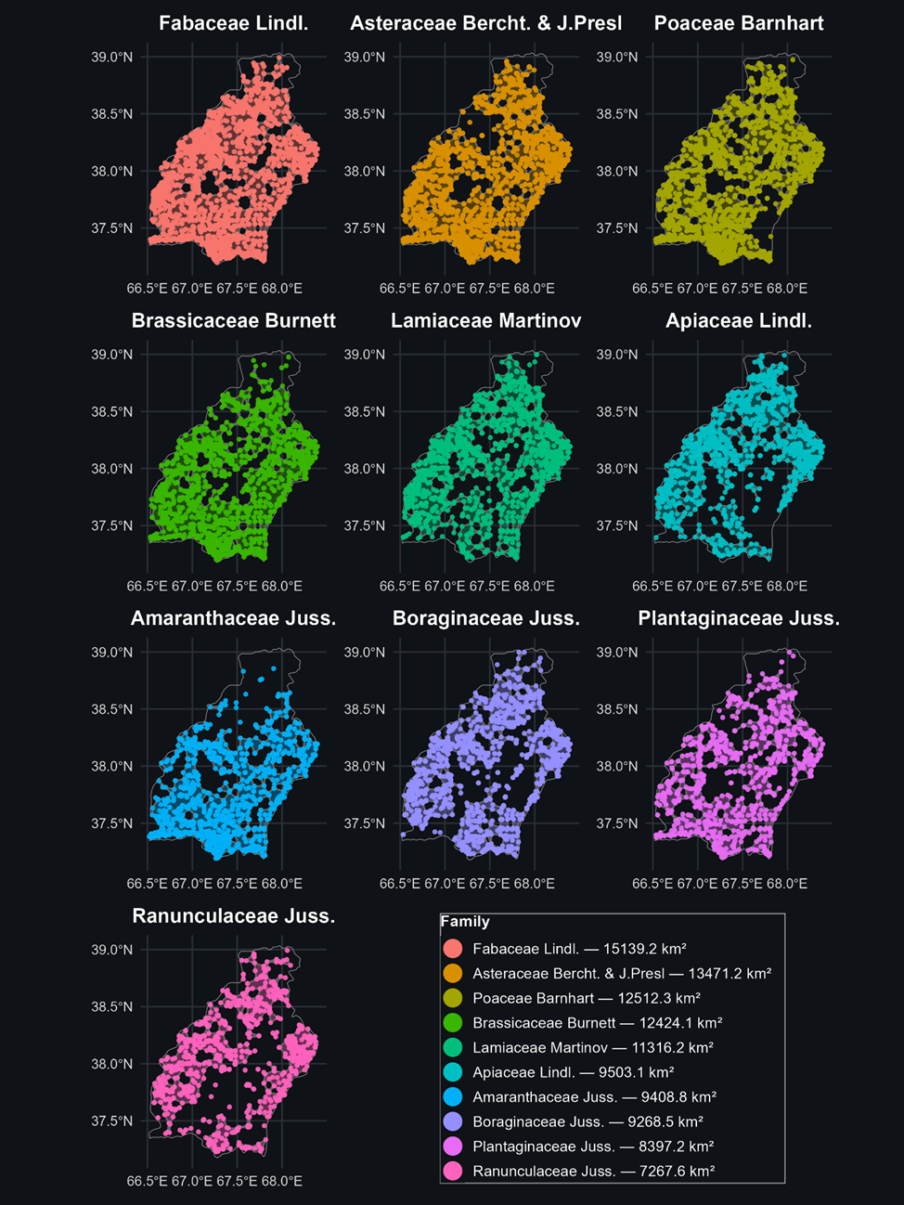
Fig. 2. Ranking of the floras of ten families with the largest geographic ranges based on the convex hull approach.

3.3. Ecological dominance: PCA and niche breadth

Principal Component Analysis (PCA) showed that the majority of environmental variation was captured by the first component. PC1 explained 83.4% of the total variance and primarily represented a gradient associated with bioclimatic variables, whereas PC2 accounted for 9.8% of the variance, reflecting secondary environmental differentiation (Fig. 3). Variable loadings indicated that bioclimatic factors were the main drivers along PC1, while soil cation exchange capacity (CEC) contributed strongly to PC2, representing an independent edaphic gradient. The distribution of points in PCA space revealed a wide range of environmental conditions, indicating that species within different families are adapted to diverse ecological settings.
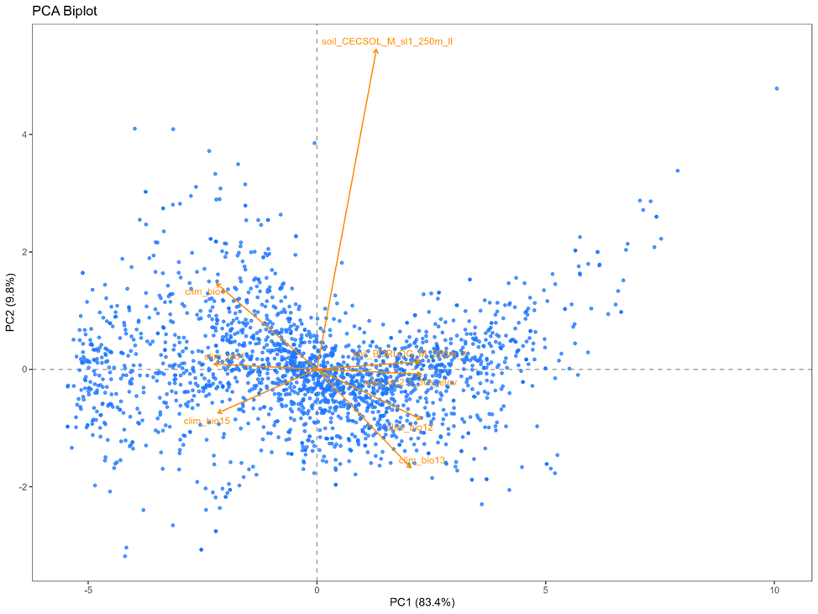
Fig. 3. PCA biplot showing the distribution of species along the first two principal components (PC1 and PC2) based on environmental variables.

According to the niche breadth analysis, the highest ecological breadth values were recorded for Plumbaginaceae (136.86), Thymelaeaceae (132.41), Convolvulaceae (125.39), and Polygonaceae (122.78). High values were also observed for Gentianaceae (119.50) and Orchidaceae (114.74). Intermediate ecological breadth was found in Euphorbiaceae (113.40), Poaceae (107.49), Juncaceae (104.82), and Scrophulariaceae (102.69) (Fig. 4). The results indicate that ecological breadth does not directly correspond to taxonomic richness. For example, Asteraceae, Fabaceae, and Brassicaceae, despite their high taxonomic diversity, did not rank among the leading families in terms of niche breadth. In contrast, some families with lower species richness exhibited higher ecological breadth. This discrepancy suggests that ecological adaptability and taxonomic diversification reflect different underlying processes. Therefore, the combined use of PCA and niche-breadth metrics is essential for a comprehensive assessment of ecological dominance.

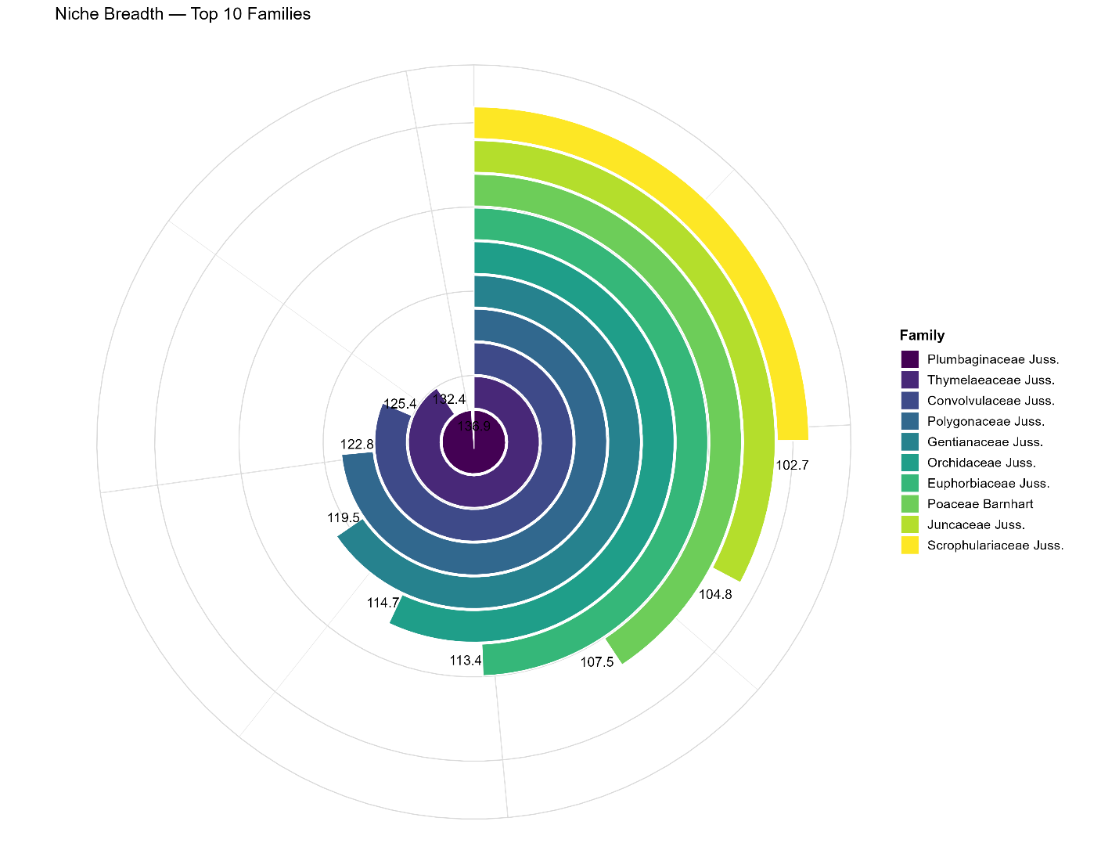
Fig. 4. Ecological stability of the top ten floristic families based on niche breadth values.

3.4. Taxonomic diversity: Shannon Diversity Index (SDI)

Taxonomic diversity of floristic families was assessed using the Shannon Diversity Index (SDI). The results revealed considerable variation in taxonomic diversity among families (Fig. 5). The highest SDI value was recorded for Fabaceae (4.77), followed by Asteraceae (4.67). Poaceae (4.12) and Lamiaceae (4.11) also exhibited relatively high taxonomic diversity. Intermediate values were observed for Apiaceae (3.90) and Brassicaceae (3.87). Lower SDI values were recorded for Ranunculaceae (3.65) and Amaranthaceae (3.57), while the lowest values were in Caryophyllaceae (3.46) and Boraginaceae (3.44). The high SDI values of Fabaceae and Asteraceae indicate a relatively complex and well-balanced taxonomic structure within these families. Although Poaceae and Lamiaceae also showed high diversity, their values were lower than those of the leading families. Overall, the SDI results demonstrate that the taxonomic component varies considerably among families and plays a crucial role in the subsequent integrative PSI assessment.

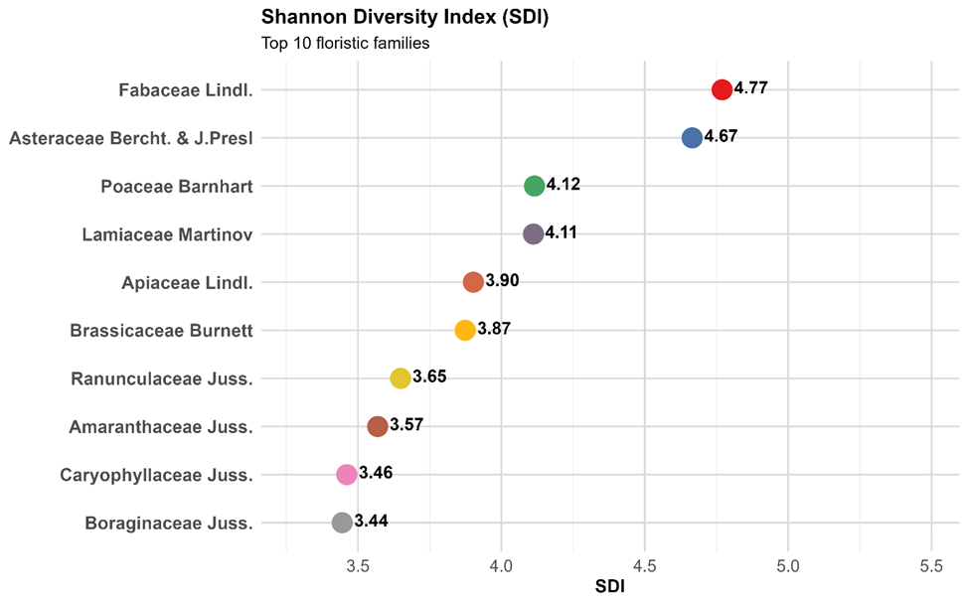
Fig. 5. Shannon diversity index (SDI) values for the top 10 floristic families in the flora of Surkhandarya, showing differences in taxonomic diversity among families.

3.5. Integrated assessment: Polymorph Stability Index (PSI)

The Polymorph Stability Index (PSI) integrates spatial, ecological, and taxonomic indicators into a single composite measure of floristic family dominance. The results revealed substantial variation in overall dominance among families (Fig. 6). The highest PSI value was recorded for Fabaceae (0.874), followed by Asteraceae (0.801), Poaceae (0.732), and Lamiaceae (0.726). Brassicaceae and Apiaceae showed identical values (0.674). Intermediate PSI values were observed for Boraginaceae (0.615) and Ranunculaceae (0.586), while lower values were recorded for Amaryllidaceae (0.574) and Caryophyllaceae (0.569). The PSI ranking indicates that the highest-ranked families generally exhibit a balanced combination of spatial coverage, ecological adaptability, and taxonomic diversity. In contrast, some families showed high values in individual components but lower overall PSI due to weaker performance in other dimensions.
These findings demonstrate that floristic dominance cannot be adequately captured by a single metric, and that an integrative, multidimensional approach such as PSI provides a more comprehensive assessment of floristic structure.

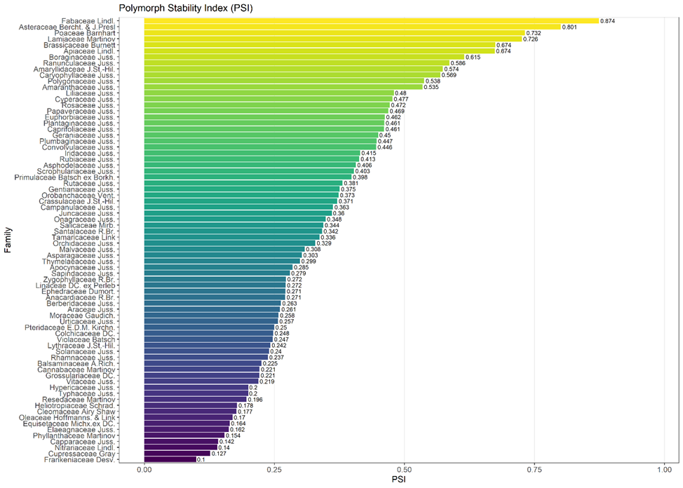
Fig. 6. PSI-based ranking of floristic families in Surkhandarya.

4. DISCUSSION

4.1 Integrated dominance of floristic families and global patterns

The findings from this study demonstrate that the dominance of polymorphic floristic families in the Surkhandarya flora is not determined solely by taxonomic richness, but rather by the integrated influence of spatial coverage, ecological adaptability, and internal diversity. This finding is consistent with contemporary macroecological frameworks, which emphasize that plant diversity is shaped by the combined effects of climatic, edaphic, and topographic gradients (Bañares-de-Dios et al., 2022; Dagne & Birhanu, 2023; Fine, 2015).
The findings can also be interpreted within the framework of classical florogenetic theory. As noted by Kamelin (2017), flora represents a historically structured system of floristic complexes with diverse origins, rather than a simple assemblage of species. From this perspective, the dominant families identified in Surkhandarya reflect not only present-day ecological filtering, but also long-term evolutionary and florogenetic processes.

4.2 Dominance of Fabaceae, Asteraceae, and Poaceae: global and regional context

The high PSI values observed for Fabaceae, Asteraceae, and Poaceae are consistent with their global ecological success (Ma et al., 2024). The dominance of Fabaceae can be attributed to its ecological versatility, particularly its ability to fix atmospheric nitrogen, which enables it to thrive in nutrient-poor soils (Vitousek et al., 2013; Siddiqui, 2025). Asteraceae, in contrast, achieve dominance through its broad ecological amplitude and effective dispersal strategies, allowing it to occupy diverse biogeographical regions (Tackenberg et al., 2003; Mandel et al., 2019). Poaceae are distinguished by high ecological plasticity and rapid adaptation to environmental changes, particularly in open and semi-arid environments (Linder, 2018; Mouillot et al., 2013).
The findings are also consistent with florogenetic interpretations, in which dominant families are considered components of a historically formed floristic core (Kamelin, 2017). Furthermore, while classical floristic studies often present these families in the order Asteraceae–Fabaceae–Poaceae based on taxonomic richness (Kamelin, 1973), the PSI-based ranking (Fabaceae–Asteraceae–Poaceae) reflects differences in evaluation criteria. Specifically, PSI integrates spatial distribution, ecological plasticity, and internal diversity, providing a more comprehensive assessment of floristic dominance.

4.3 Mismatch between taxonomic diversity and ecological breadth

The results of this study reveal no direct relationship between taxonomic richness (SDI) and ecological niche breadth. This finding is consistent with ecological theory suggesting that niche breadth does not necessarily scale with species richness (Devictor et al., 2010), although species with broader ecological niches tend to occupy wider geographic ranges (Slatyer et al., 2013). This pattern reflects the independent trajectories of ecological and evolutionary processes.
Accordingly, the results confirm that assessing polymorphism based solely on species richness is insufficient (Fleishman et al., 2006; Morris et al., 2014). Kamelin’s florogenetic concept similarly emphasizes that taxonomic richness and ecological amplitude are shaped by different evolutionary pathways and do not necessarily correspond (Kamelin, 1973).

4.4 Spatial distribution and the role of landscape heterogeneity

The results obtained using the KDE and triangulation–threshold approaches demonstrate that the distribution of floristic families is closely associated with landscape heterogeneity. The complex relief of the Surkhandarya region, characterized by the combination of mountain systems, valleys, and foothills, creates pronounced spatial differentiation in floristic patterns. Similar patterns have been reported in other regions, where KDE and hull-based methods have proven effective tools for delineating species distributions (Jana et al., 2024; Meyer et al., 2020).
As noted by Tolmachev (1986), regional floras often comprise multiple floristic elements, resulting in high spatial heterogeneity.

4.5 Methodological innovation: advantages of the PSI model

The Polymorph Stability Index (PSI), introduced in this study, represents a novel integrative approach to evaluating floristic families. By combining spatial, ecological, and taxonomic dimensions, PSI provides a more comprehensive representation of the actual ecological dominance of plant families.
While traditional approaches are primarily based on species richness (Fleishman et al., 2006), such methods often fail to capture the complexity of ecological patterns. In contrast, modern ecological analyses emphasize the importance of multidimensional indicators (Mouillot et al., 2013). The PSI framework effectively addresses this gap by integrating multiple components into a unified assessment.

4.6 Regional significance in the Central Asian context

The flora of Central Asia is characterized by high levels of endemism, complex topographic structure, and pronounced climatic gradients. Within this region, Fabaceae, Asteraceae, and Poaceae are consistently recognized as the largest and ecologically most successful families (Ma et al., 2024). The results obtained for the Surkhandarya region confirm these regional patterns and further enhance the biogeographical significance of the study.
The dominance of these families in the Surkhandarya flora, as reflected by high PSI values, indicates that their success is driven not only by contemporary ecological factors but also by historical processes of floristic development. The formation of the Central Asian flora has been shaped by the interaction of migratory and autochthonous processes, which are considered key determinants of its current floristic structure (Zakirov, 1976).
These findings are also consistent with classical studies demonstrating high floristic richness and structural complexity in mountainous regions (Krasovskaya & Levichev, 1986). Consequently, the identified dominant families constitute the core structural and functional backbone of the Surkhandarya flora, playing a central role in its ecological stability and biogeographical organization.

4.7 Limitations and future directions

Despite the robustness of the findings, several limitations should be acknowledged. First, the uneven spatial distribution of georeferenced data may have influenced the spatial metrics of certain floristic families. Second, although the environmental variables used in the analysis capture the main climatic and edaphic gradients, factors such as microclimate, anthropogenic pressure, and biotic interactions were not fully incorporated. Third, generalization at the family level may obscure important ecological differences at the species level.
Future research should focus on applying the PSI framework at species and genus levels, integrating functional trait and phylogenetic data, and incorporating climate change scenarios to further enhance its analytical potential.

CONCLUSION

This study demonstrates that the dominance of polymorphic floristic families in the flora of Surkhandarya is determined by multiple factors rather than by taxonomic richness alone. The results indicate that family-level dominance is shaped by the integrated effects of spatial distribution, ecological adaptability, and internal diversity.
Spatial analyses revealed that Fabaceae, Asteraceae, and Poaceae exhibit the highest levels of geographic coverage and spatial intensity within the study area. Ecological analyses further showed that ecological breadth is not directly correlated with taxonomic richness, highlighting the independent roles of ecological and evolutionary processes.
The Polymorph Stability Index (PSI) proved to be an effective tool for the integrated assessment of floristic dominance, identifying families with high PSI values as the core polymorphic components of the regional flora.
Overall, the findings emphasize that assessing polymorphism requires a multidimensional approach that integrates spatial, ecological, and taxonomic components. The proposed PSI framework offers a transferable methodology applicable to other regions for comprehensive floristic analysis.

Acknowledgements

This research was carried out within the framework of the State Program of the Institute of Botany, Academy of Sciences of the Republic of Uzbekistan, entitled “Digital Nature: Development of a Digital Platform for the Flora of Central Uzbekistan” (2025–2029).
The study was also supported by the fundamental research projects “Taxonomic revision of polymorphic families in the flora of Uzbekistan” (A-FA-2021-427) and “Transboundary biodiversity hotspots of Uzbekistan and their current status” (FL-9024093685), as well as applied projects “Bioclimatic and geospatial analysis of medicinal plant resources of the Republic, patterns of adaptation and distribution (on the example of the genus Ferula L.)” (FL-9524115063) and “Preparation of the first Uzbek-language edition of the Flora of Uzbekistan” (AL-9224104450).

REFERENCES

Bañares-de-Dios, G., Peña-Claros, M., de Camargo, P. B., Poorter, L. (2022). Soil and climate drive floristic composition in tropical forests: A literature review. Frontiers in Ecology and Evolution, 10, 866905. https://doi.org/10.3389/fevo.2022.866905
Beck, J., Böller, M., Erhardt, A., Schwanghart, W. (2014). Spatial bias in the GBIF database and its effect on modeling species' geographic distributions. Ecological Informatics, 19, 10–15. https://doi.org/10.1016/j.ecoinf.2013.11.002
Dagne, Y., Birhanu, L. (2023). Floristic composition and plant community distribution along environmental gradients in Guard dry Afromontane forest of Northwestern Ethiopia. BMC Ecology and Evolution, 23, 43. https://doi.org/10.1186/s12862-023-02154-6
Devictor, V., Clavel, J., Julliard, R., Lavergne, S., Mouillot, D., Thuiller, W., Venail, P., Villéger, S., Mouquet, N. (2010). Defining and measuring ecological specialization. Journal of Applied Ecology, 47(1), 15–25. https://doi.org/10.1111/j.1365-2664.2009.01744.x
Dormann, C. F. et al. (2013). Collinearity: a review of methods to deal with it and a simulation study evaluating their performance. Ecography, 36(1), 27–46. https://doi.org/10.1111/j.1600-0587.2012.07348.x
Elith, J., Leathwick, J. R. (2009). Species distribution models: ecological explanation and prediction across space and time. Annual Review of Ecology, Evolution, and Systematics, 40(1), 677–697. https://doi.org/10.1146/annurev.ecolsys.110308.120159
Fick, S. E., Hijmans, R. J. (2017). WorldClim 2: new 1-km spatial resolution climate surfaces for global land areas. International Journal of Climatology, 37(12), 4302–4315. https://doi.org/10.1002/joc.5086
Fine, P. V. A. (2015). Ecological and evolutionary drivers of geographic variation in species diversity. Annual Review of Ecology, Evolution, and Systematics, 46(1), 369–392. https://doi.org/10.1146/annurev-ecolsys-112414-054102
Fleishman, E., Noss, R. F., Noon, B. R. (2006). Utility and limitations of species richness metrics for conservation planning. Ecological Indicators, 6(3), 543–553. https://doi.org/10.1016/j.ecolind.2005.07.005
Franklin, J. (2010). Mapping Species Distributions: Spatial Inference and Prediction. Cambridge University Press.
Haq, S. M., Khoja, A. A., Lone, F. A., Waheed, M., Bussmann, R. W., Mahmoud, E. A., & Elansary, H. O. (2023). Floristic composition, life history traits and phytogeographic distribution of forest vegetation in the Western Himalaya. Frontiers in Forests and Global Change, 6, 1169085. https://doi.org/10.3389/ffgc.2023.1169085
Hengl, T., de Jesus, J. M., Heuvelink, G. B. M., et al. (2017). SoilGrids250m: global gridded soil information based on machine learning. PLoS ONE, 12(2), e0169748. https://doi.org/10.1371/journal.pone.0169748
Jolliffe, I. T., Cadima, J. (2016). Principal component analysis: a review and recent developments. Philosophical Transactions of the Royal Society A: Mathematical, Physical and Engineering Sciences, 374(2065), 20150202. https://doi.org/10.1098/rsta.2015.0202
Kamelin, R. V. (1973). Florogeneticheskiy analiz estestvennoy flory gornoy Sredney Azii.
Kamelin, R. V. (2017). Flora pestrotsvetnykh obnazheniy Sredney Azii. Turczaninowia, 20(4), 125–151.
Kamelin, R. V. (2017). Istoriya flory Seredinnoy Evrazii. Turczaninowia, 20(1), 5–29.
Khan, I., Khan, W. M., Khalid, S., Hayat, K., & Din, S. H. A. S. (2025). Floristic diversity and ecological attributes of the vegetation in Behram Khel, Lakki Marwat, Khyber Pakhtunkhwa, Pakistan. Pure and Applied Biology (PAB), 14(4). http://doi.org/10.19045/bspab.2025.140099
Körner, C. (2007). The use of altitude in ecological research. Trends in Ecology & Evolution, 22(11), 569–574. https://doi.org/10.1016/j.tree.2007.09.006
Krasovskaya, L. S., Levichev, I. G. (1986). Flora Chatkalskogo zapovednika. Tashkent: Fan.
Legendre, P., Legendre, L. (2012). Numerical ecology (Vol. 24). Elsevier.
Linder, H. P., Lehmann, C. E. R., Archibald, S., Osborne, C. P., Richardson, D. M. (2018). Global grass (Poaceae) success underpinned by traits facilitating colonization, persistence and habitat transformation. Biological Reviews, 93(2), 1125–1144. https://doi.org/10.1111/brv.12388
Ma, S., Li, W., Tojibaev, K. S., Turginov, O., Yang, W., Ma, K. (2024). Regionwide and nationwide floristic richness reveal vascular plant diversity in Central Asia. Plants, 13(16), 2275. https://doi.org/10.3390/plants13162275
Mandel, J. R., Dikow, R. B., Siniscalchi, C. M., Thapa, R., Watson, L. E., Funk, V. A. (2019). A fully resolved backbone phylogeny reveals numerous dispersals and explosive diversifications throughout the history of Asteraceae. Proceedings of the National Academy of Sciences, 116(28), 14083–14088. https://doi.org/10.1073/pnas.1903871116
Meyer, L., Diniz-Filho, J. A. F., Lohmann, L. G. (2017). A comparison of hull methods for estimating species ranges and richness maps. Plant Ecology & Diversity, 10(5–6), 389–401. https://doi.org/10.1080/17550874.2018.1425505
Morris, E. K., Caruso, T., Buscot, F., Fischer, M., Hancock, C., Maier, T. S., Meiners, T., Müller, C., Obermaier, E., Prati, D., Socher, S. A., Sonnemann, I., Wäschke, N., Wubet, T., Wurst, S., Rillig, M. C. (2014). Choosing and using diversity indices. Ecology and Evolution, 4(18), 3514–3524. https://doi.org/10.1002/ece3.1155
Mouillot, D., Graham, N. A. J., Villéger, S., Mason, N. W. H., Bellwood, D. R. (2013). A functional approach reveals community responses to disturbances. Trends in Ecology & Evolution, 28(3), 167–177. https://doi.org/10.1016/j.tree.2012.10.004
R Core Team (2024). R: A language and environment for statistical computing. R Foundation for Statistical Computing.
Siddiqui, S. (2025). Global patterns and drivers of species and genera richness of Fabaceae. Frontiers in Plant Science, 16, 1581814. https://doi.org/10.3389/fpls.2025.1581814
Slatyer, R. A., Hirst, M., Sexton, J. P. (2013). Niche breadth predicts geographical range size. Ecology Letters, 16(8), 1104–1114. https://doi.org/10.1111/ele.12140
Tackenberg, O., Poschlod, P., Bonn, S. (2003). Assessment of wind dispersal potential in plant species. Ecological Monographs, 73(2), 191–205. https://doi.org/10.1890/0012-9615(2003)073[0191:AOWDPI]2.0.CO;2
Thiers, B. (continuously updated). Index Herbariorum: A global directory of public herbaria and associated staff. New York Botanical Garden’s Virtual Herbarium. Available at: http://sweetgum.nybg.org/science/ih/
Tolmachev, A. I. (1986). Problemy florogeneza. Novosibirsk: Nauka.
Vitousek, P. M., Menge, D. N. L., Reed, S. C., Cleveland, C. C. (2013). Biological nitrogen fixation: Rates, patterns and ecological controls in terrestrial ecosystems. Philosophical Transactions of the Royal Society B, 368(1621), 20130119. https://doi.org/10.1098/rstb.2013.0119
Zakirov, K. Z. (1976). Rastitelnyy pokrov Uzbekistana i puti ego ratsionalnogo ispolzovaniya.

